**Rough material requirements:**

1. Can withstand pressures of up to 180mmHg (3.5psi)
   * Depending on how we make the chamber this requirement will be more focused on the seams/fittings and glued surfaces rather than the material itself. Most hard plastics will withstand this pressure easily
2. Biocompatible
3. Compatible with EtO
   * <https://www.industrialspec.com/resources/plastics-sterilization-compatibility/>
     + Good table of different plastics and their compatibility with different sterilization methods
4. Clear (allows for visual inspection of function, accurate adjustment of volumes)
5. Reasonable price (compliance chamber should not be $1000)
   * Easily machinable or stock cylinder source would be best

**Candidates:**

* Acrylic/PMMA
  + <https://www.ipolymer.com/pdf/Acrylic.pdf>
  + <https://www.acmeplastics.com/acrylic-vs-polycarbonate>
  + <https://www.vanderveerplastics.com/compare-materials.html?sel1=acrylic&sel2=polycarbonate>
* Polycarbonate
  + <https://www.ipolymer.com/pdf/Polycarbonate.pdf>
  + <https://www.mddionline.com/medical-applications-polycarbonate>
    - Polycarb is a popular material in medicine, used in many devices and tubing
    - Stronger than acrylic, but less transparent (only slightly)
    - More expensive
    - Easier to machine (would only really make a difference if we machine it ourselves, acrylic is stiffer → easier to shatter during the machining process)

**Polycarb seems to be the better fit, but either will work for our purposes**

**Volume Requirement**

See derivation PDF

**Pressure Requirement**

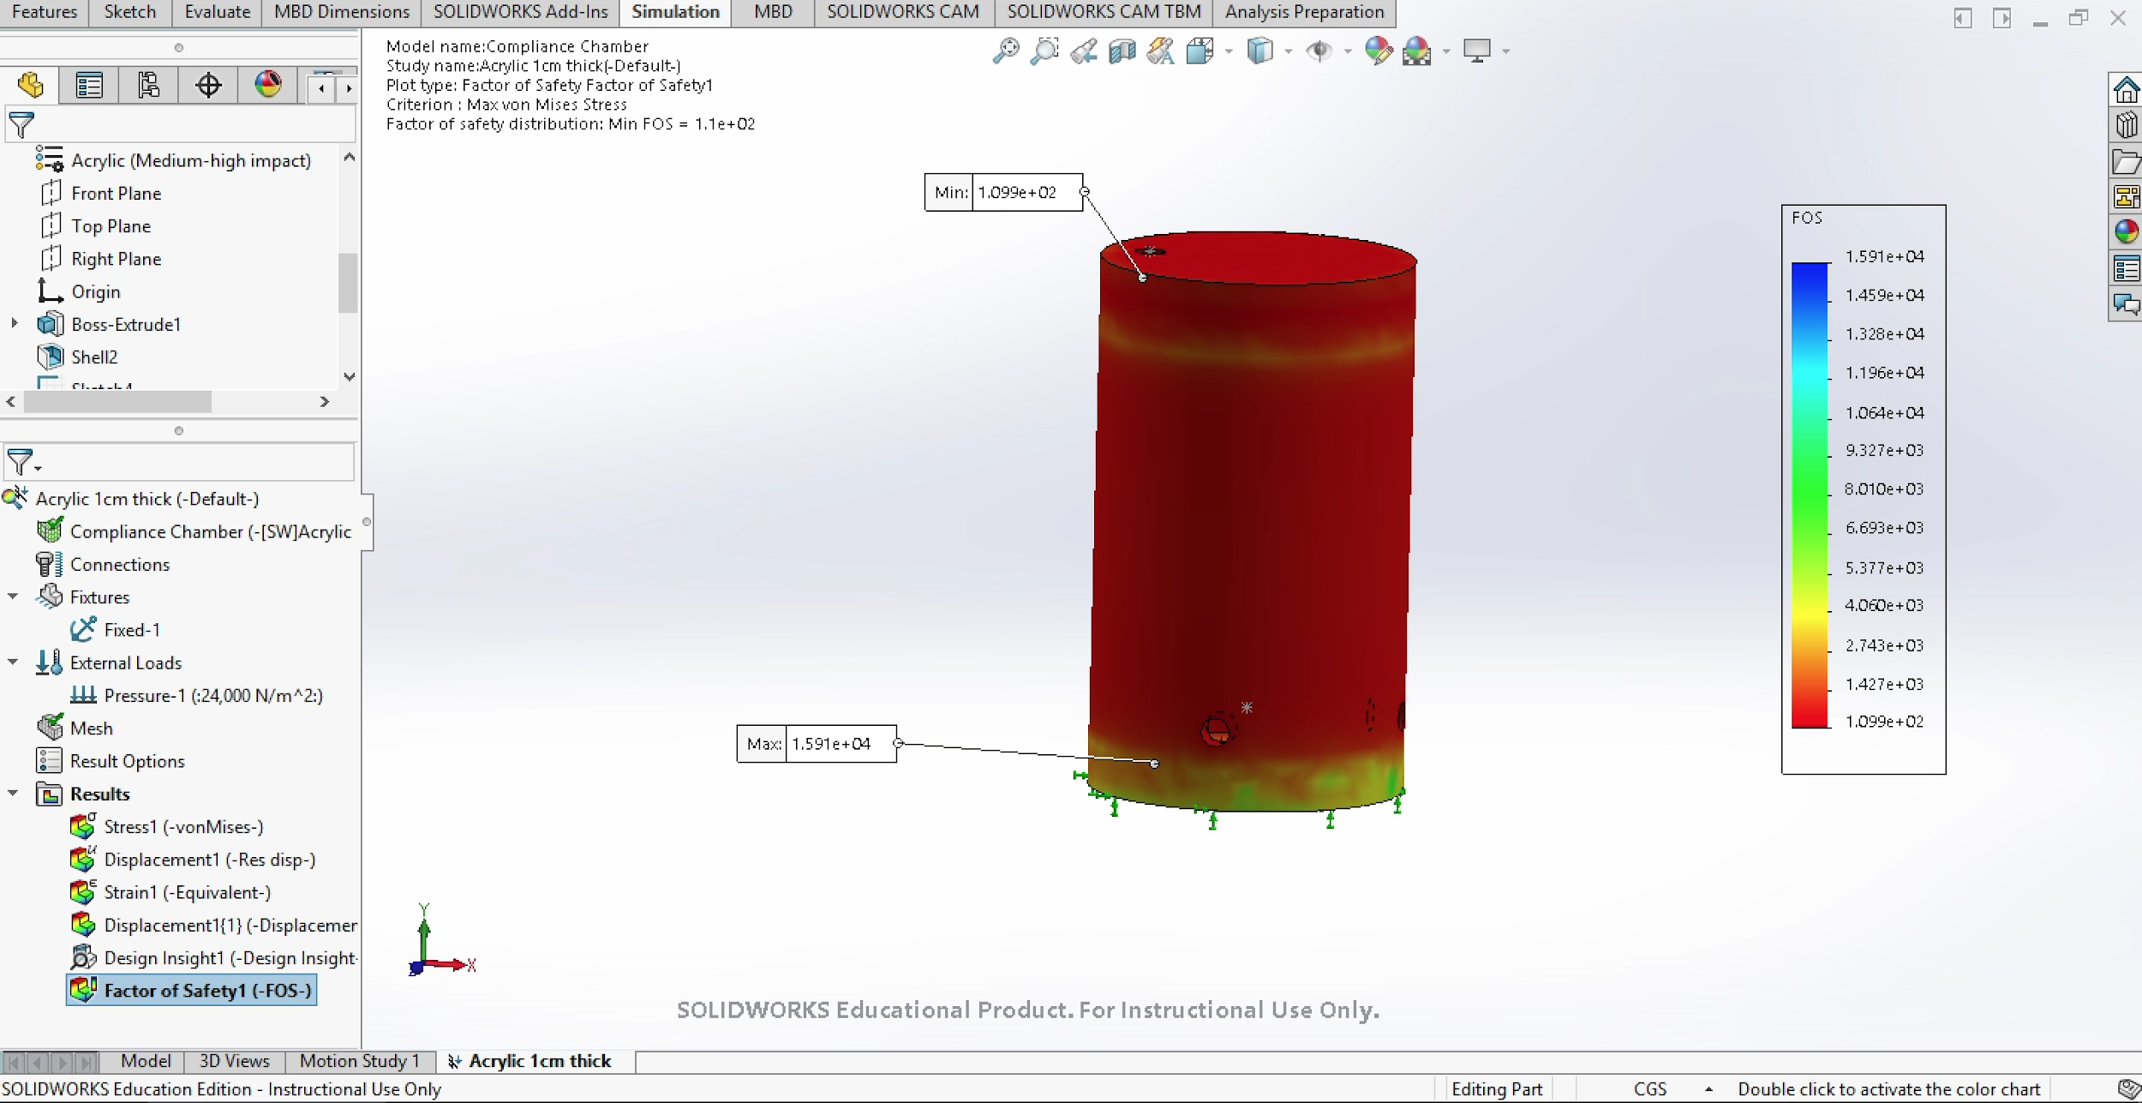

Solidworks simulation shows that with 1cm thick walls of Acrylic (PMMA) our factor of safety at 180mmHg would be over 100 → this is more than safe. Polycarbonate is a stronger material so this design would work for either material.

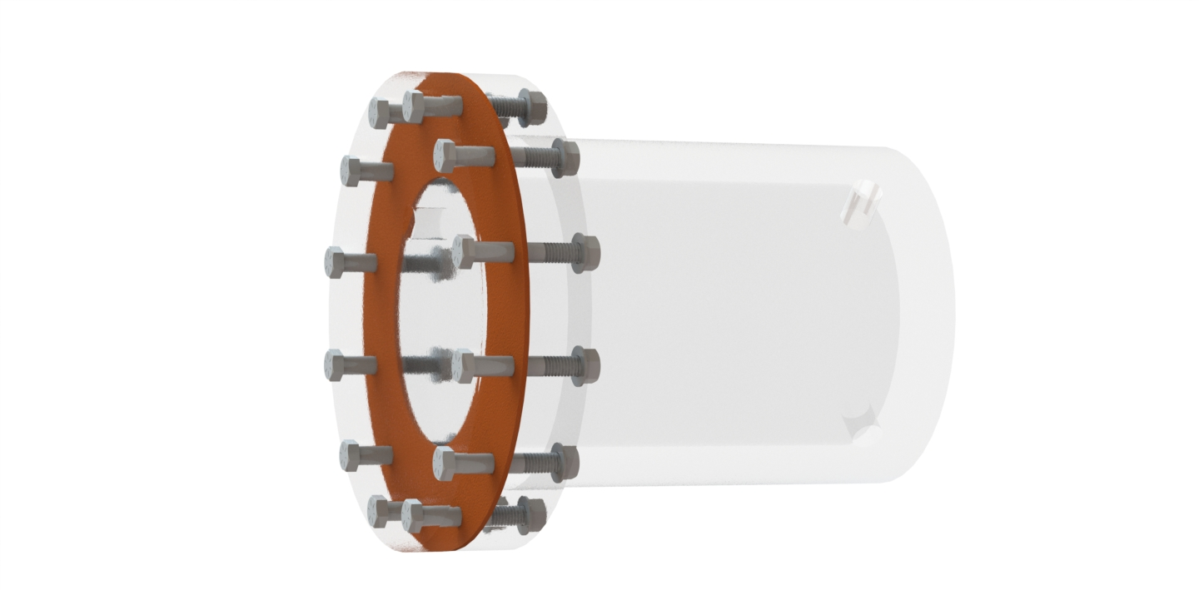

**Next Steps**

The only remaining unknown for the compliance chamber is the inlet/outlet hole sizes. These will hopefully be known soon as we decide on fitting types and tubing sizes. Finally, we need to look into designing the chamber so that it is manufacturable. The design to the right is a first pass concept featuring a machined cylinder with a flange that is sealed by a cap / rubber disk fastened with screws. While this design would work, the big cylinder/flange piece is not very manufacturable

Design update:

Having a three way valve connected to a single inlet on the bottom of the compliance chamber would be the way to go.

**Manufacturing**

**Contracting**

* Most straightforward choice of manufacturing method is CNC. Plenty of companies do CNC machining in both acrylic and polycarbonate
* One quote was fucking 3500$$$
* Need to modify the current design if we are going to contract it
  + Large cylinder piece with the flange is not very manufacturable. CNC starts with a block of material, machining that cylinder means a ton of material is needed

**Stock acrylic + acrylic cement**

* Can change design to just a cylinder with two caps, buy stock acrylic from mcmaster
  + <https://www.mcmaster.com/acrylic>
* Probably use some type of resin to join them
  + Weld-on 4
  + <https://www.gogsg.com/ASSETS/DOCUMENTS/ITEMS/EN/ips4-04_spec.pdf>
* Drill holes and tap them ourselves where necessary
* Maybe 200$, leaves room for messing up

Dimensions + links for parts we would order to build it

Systemic

* + 4” ID, 5.82 - 6” height
  + [~~8486K575~~](https://www.mcmaster.com/8486K575) ~~main walls~~
  + [~~1221T95~~](https://www.mcmaster.com/1221T95) ~~bottom disc~~
  + [~~1221T39~~](https://www.mcmaster.com/1221T39) ~~2x Top discs~~
* Pulmonary
  + 5” ID, 8.75-9.32” height
  + [8486K585](https://www.mcmaster.com/8486K585) main walls
  + [8581K37](https://www.mcmaster.com/8581K37) bottom disc
  + [~~https://www.mcmaster.com/8581K39~~](https://www.mcmaster.com/8581K39) ~~2x Top discs~~
* **For the top and bottom / flange components, you would get a cast acrylic SHEET and just laser cut it. Noah has a ton of acrylic stock we can use so don’t buy yet**
* Weld-on 4
  + <https://www.amazon.com/Weldon-Applicator-Bottle-Pint-10308/dp/B00TCUJ7A8/ref=sr_1_1?crid=3A2VFODSMVZL6&keywords=weld-on+4&qid=1581025433&s=industrial&sprefix=weld-on%2Cindustrial%2C140&sr=1-1>
  + <https://www.gogsg.com/ASSETS/DOCUMENTS/ITEMS/EN/ips4-04_spec.pdf>
  + <https://www.gogsg.com/ASSETS/DOCUMENTS/ITEMS/EN/IPS4-01_MSDS.pdf>

**Blown glass?**

* **nah**

**Pressure Release Valve**

* Should release pressure once pressure in compliance chamber exceeds 3.5 psi
* Possible products
  + [4703K54](https://www.mcmaster.com/4703K54)
  + [48935K25](https://www.mcmaster.com/48935K25) (cheapest, smallest)
  + [7844K52](https://www.mcmaster.com/7844K52)

**O-Rings**

Literature

* [Parker O-Ring Handbook](https://www.parker.com/Literature/O-Ring%20Division%20Literature/ORD%205700.pdf)
  + **Groove dimensions for a face seal:page 4-18**
  + Compression force required: Figures 2-4 through 2-8 in Section II

Products

* <https://www.mcmaster.com/o-rings>
* #254 should work [9452K355](https://www.mcmaster.com/9452K355)
* Also 161
  + .077 +/- .003” depth X 0.122 +/- .002” width
* 51
  + .052 +/- .002” depth X .086 +/- .002” width

**Manufacturing feedback from Noah**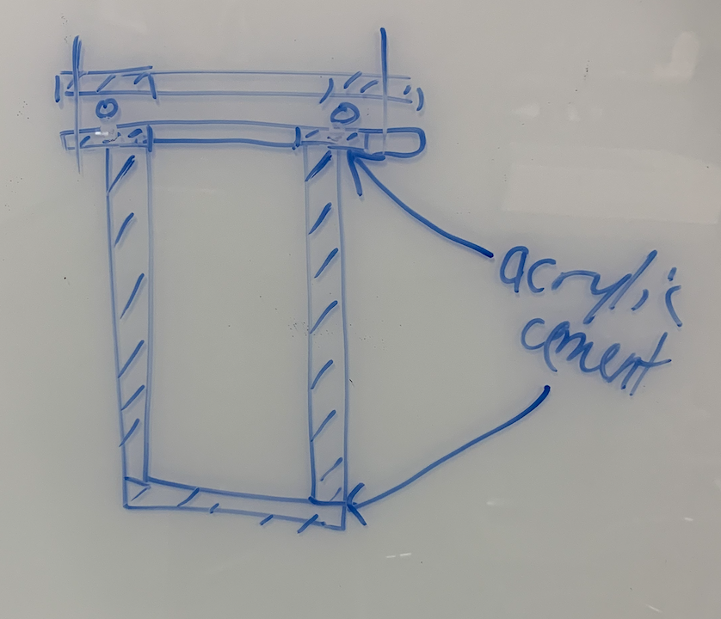

Design 1

* For the top and bottoms, get CAST acrylic SHEETS
* Cast acrylic is easier to machine, laser cutting works on either cast or extruded
* For the O-ring groove you would use laser cutting and engrave it. Would take some trial and error to get the correct specs for the O-ring
* Profile of flange + screw holes are easy to laser cut

Design 2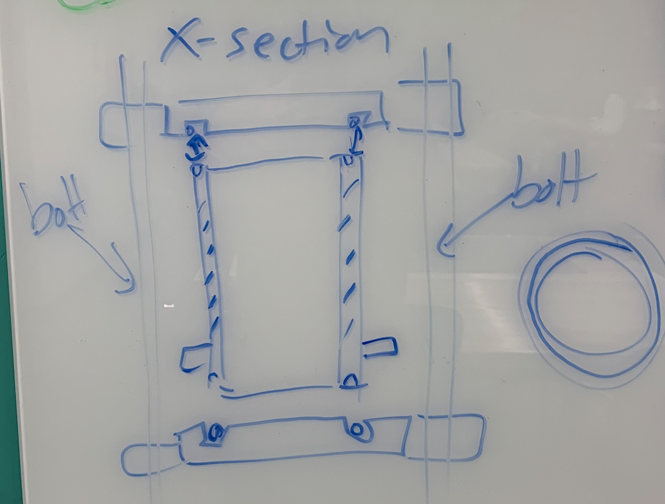

* I asked noah if he could put a groove on the top and bottom of the tube itself if the tube was thick enough
  + He said with a lathe it is doable

**Confirmed redesign:**

* Top and bottom pieces
  + Cast acrylic sheet
    - [8560K266](https://www.mcmaster.com/8560K266)
  + One inlet each
  + O-ring groove on each
    - O ring dimensions must match with tubing dimensions such that the tube edges form one face of the seal
    - [9557K142](https://www.mcmaster.com/9557K142)
      * EPDM
* Walls
  + [8486K585](https://www.mcmaster.com/8486K585) main walls
* RODS
  + 10” long, ¼”-20 stainless steel 316
  + McMaster: <https://www.mcmaster.com/90575A224>
* Cutter for machining as requested by Noah
  + <https://www.sparkfun.com/products/14853>
* Waste board for machining as requested by Noah
  + <https://www.sparkfun.com/products/14904>

Other cost-effective tank designs

<https://www.usplastic.com/catalog/item.aspx?itemid=134241&catid=835>

Notes:

EDPM is biocompatible, has excellent swell resistance, therefore we select the smaller gas and vacuum groove width from the o-ring handbook.

Delrin is biocompatible

‘

Material compatibility charts for funsies: <https://www.calpaclab.com/acetal-polyoxymethylene-chemical-compatibility-chart/#>

Info about durometer:

<https://promo.parker.com/promotionsite/oring-ehandbook/us/en/ehome/Hardness>

Info about EDPM being used in medical applications: <https://www.aceseal.com/o-ring-materials>

Biocompatibility of delrin: <https://onlinelibrary.wiley.com/doi/abs/10.1002/jbm.820190505>

List of biocompatible plastics: <https://www.google.com/imgres?imgurl=http%3A%2F%2Fzeusinc.wpengine.com%2Fwp-content%2Fuploads%2F2017%2F10%2FBiocompatibility-RESINATE-Zeus-T1.jpg&imgrefurl=https%3A%2F%2Fwww.zeusinc.com%2Fbiocompatibility-of-plastics%2F&tbnid=U1F0nTep0YrA7M&vet=10CAMQxiAoAGoXChMI8Jfaj4Lc5wIVAAAAAB0AAAAAEAY..i&docid=F7a0mIIlF303dM&w=600&h=598&itg=1&q=biocompatible%20plastics&ved=0CAMQxiAoAGoXChMI8Jfaj4Lc5wIVAAAAAB0AAAAAEAY>

**Fittings:**

Bottom T-connector: ½” NPT, ½” pipe diameter, barb, made out of acetal (same as Delrin)

[**https://www.mcmaster.com/5047K61**](https://www.mcmaster.com/5047K61)

Top T-connector:

**Nuts:**

¼”-20 Flange nut: <https://www.mcmaster.com/94842A101>

¼”-20 Cap nut: <https://www.mcmaster.com/98858A101>

Male Luer-Male ¼” NPT adapter: <https://www.mcmaster.com/51525K437>

½” NPT Stopcock: <https://www.mcmaster.com/4793K844>

TO DO:

1. Determine fittings for pressure relief and stopcock at the top of the compliance chamber
2. Determine torque spec and buy torque wrench
3. Pat ourselves on the back
4. Have a pint

**Torque Specification**

Directions: <https://www.darcoid.com/userfiles/cms/subpage/files/31/Installation.pdf>

Part 1: Calculate compressive load required for face seal o-ring application

<https://www.parker.com/literature/O-Ring%20Division%20Literature/O-Ring%20ehandbook%20pdfs/compression%20load%20force%20by%20cross%20section%2070%20and%2090%20duro.pdf>

Squeeze is 19-32%, the midpoint is ~25%

This is the ratio of deformation to the thickness of the o-ring.

Referring to the chart above, 25% squeeze results in 25 lbs per inch of o-ring circumference of compressive load.

Part 2: Calculate necessary bolt torque and spacing for the face seal

<https://mechanicalc.com/reference/bolted-joint-analysis>

1. **STOPCOCK/PRESSURE RELIEF FITTINGS**

Sterile Pressure Relief

→ NPT to Female Luer Adapter:<https://www.mcmaster.com/51525K437>

→ Luer Male to Luer Female On/Off Valve:<https://www.mcmaster.com/7033t24>

→ Male Luer Filter: Sterifix 0.2 μm; B. Braun Melsungen AG, Germany (we already have these)